1. **Create an EFS and connect it to 3 different EC2 instances. Make sure that all instances have different operating systems. For instance, Ubuntu, Red Hat Linux and Amazon Linux 2**

**Ans:**

Step I

- Created 3 Ec2 instance by using Amazon Linux 2, Ubuntu and Red hat Linux

— I just opened only port 22 security group in all the instances

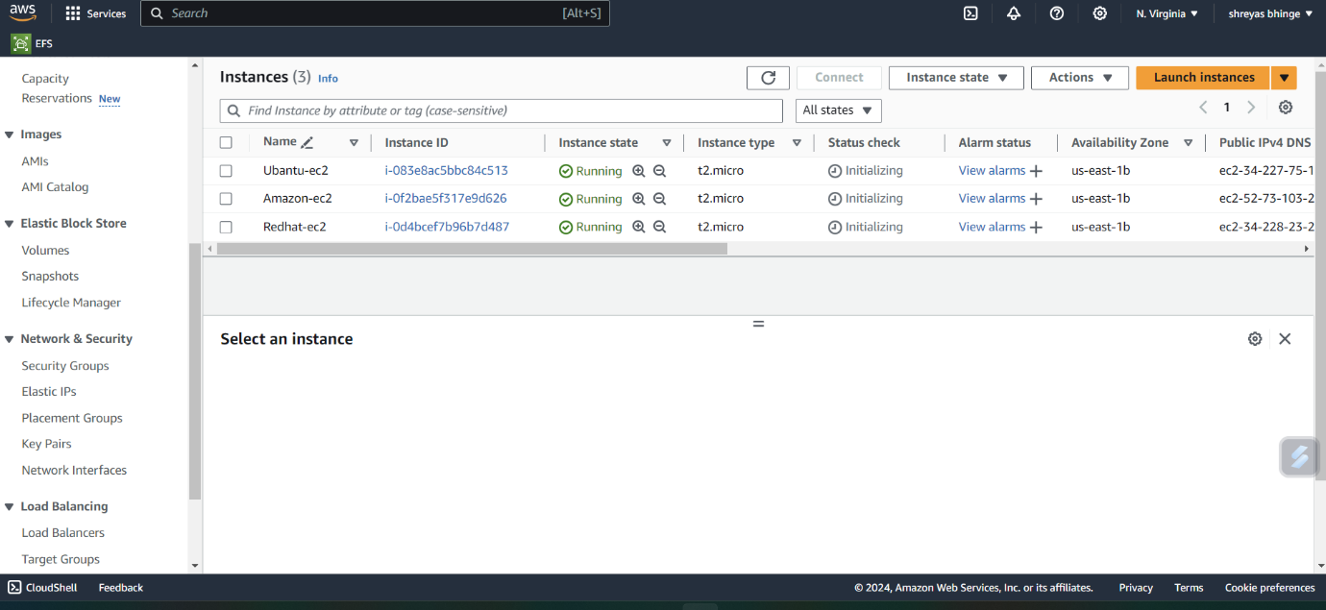

STEP 2 — Created security group for EFS Inbound type NFS port ( 2049 ) allow source

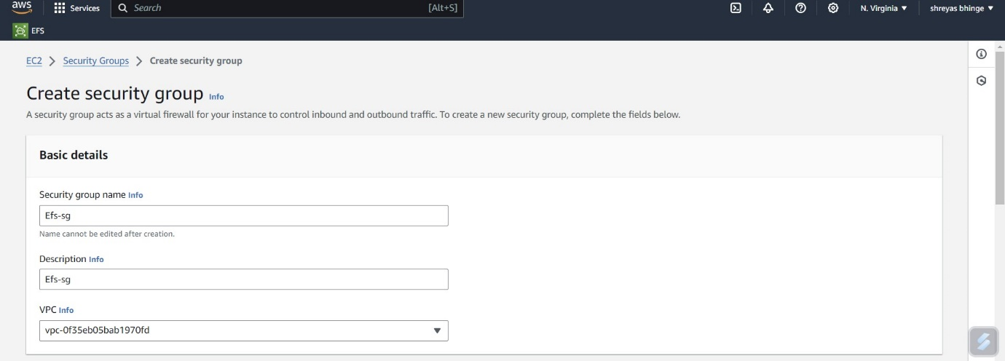

* Copied security group of every ec2 and pasted in inbound rules.

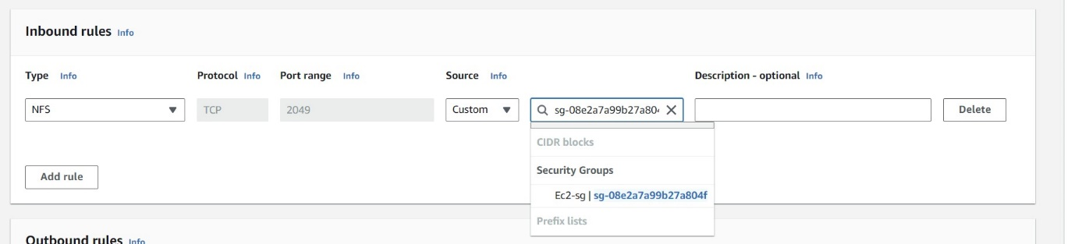

STEP 3

— Created EFS File with a name based on project (EFS_file)

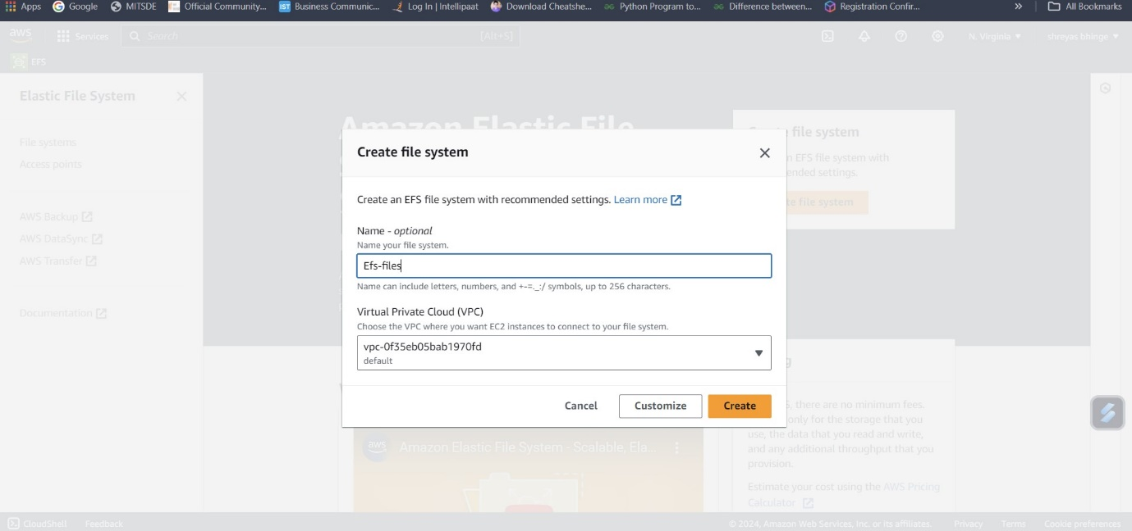

* Click customize — click next (networking)
* In networking remove all the network access where just mention only the network access you mentioned previously.

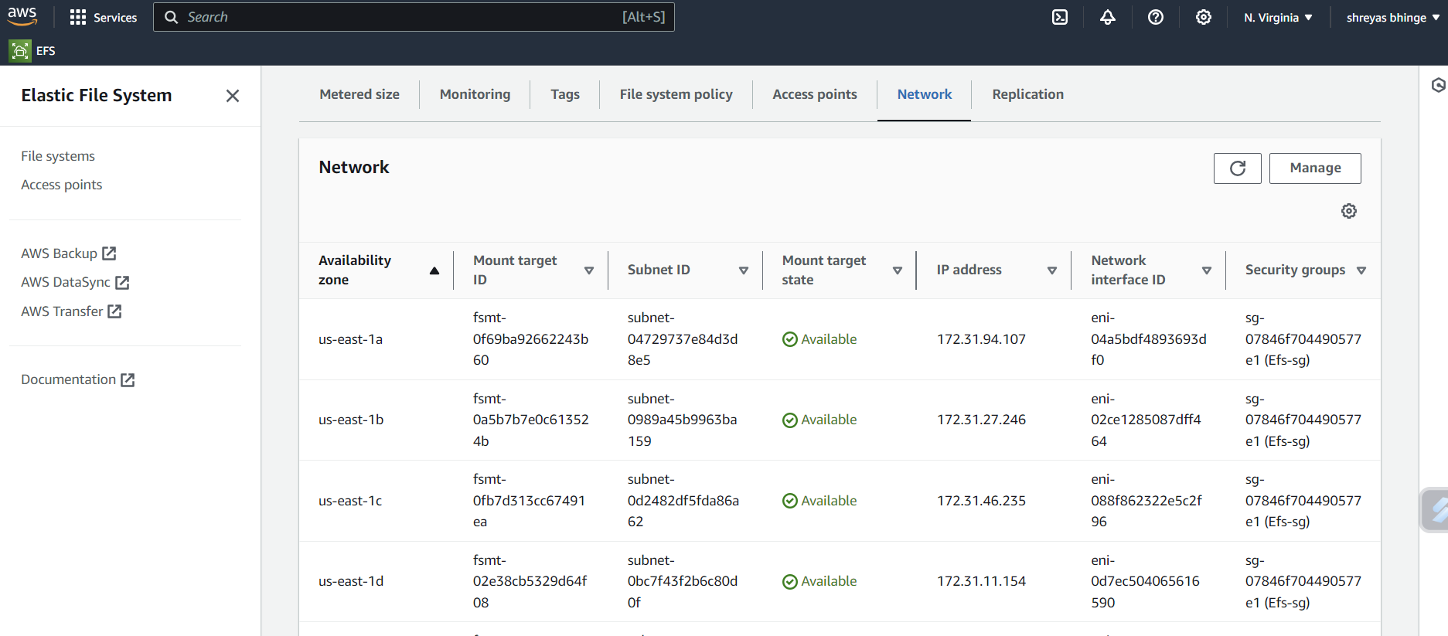

* Check availability zone and security group weather they are the same as you created in step 1 an 2.
* Click Next — Next — create.

STEP 4

1. Mounting efs to Amazon linux

Connect to the servers let's Take Amazon Linux 2 by using Ec2 instance connect.

— Use below commands

— Shift to root user

Sudo su

— Use below command to install efs utility

yum install -y amazon-efs-utils

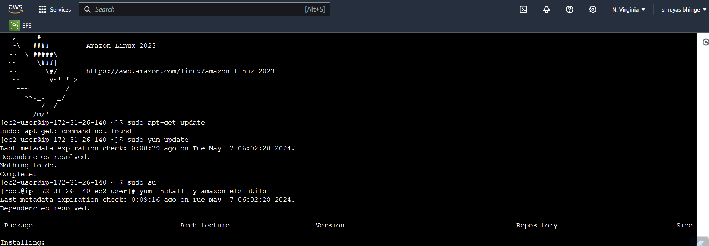

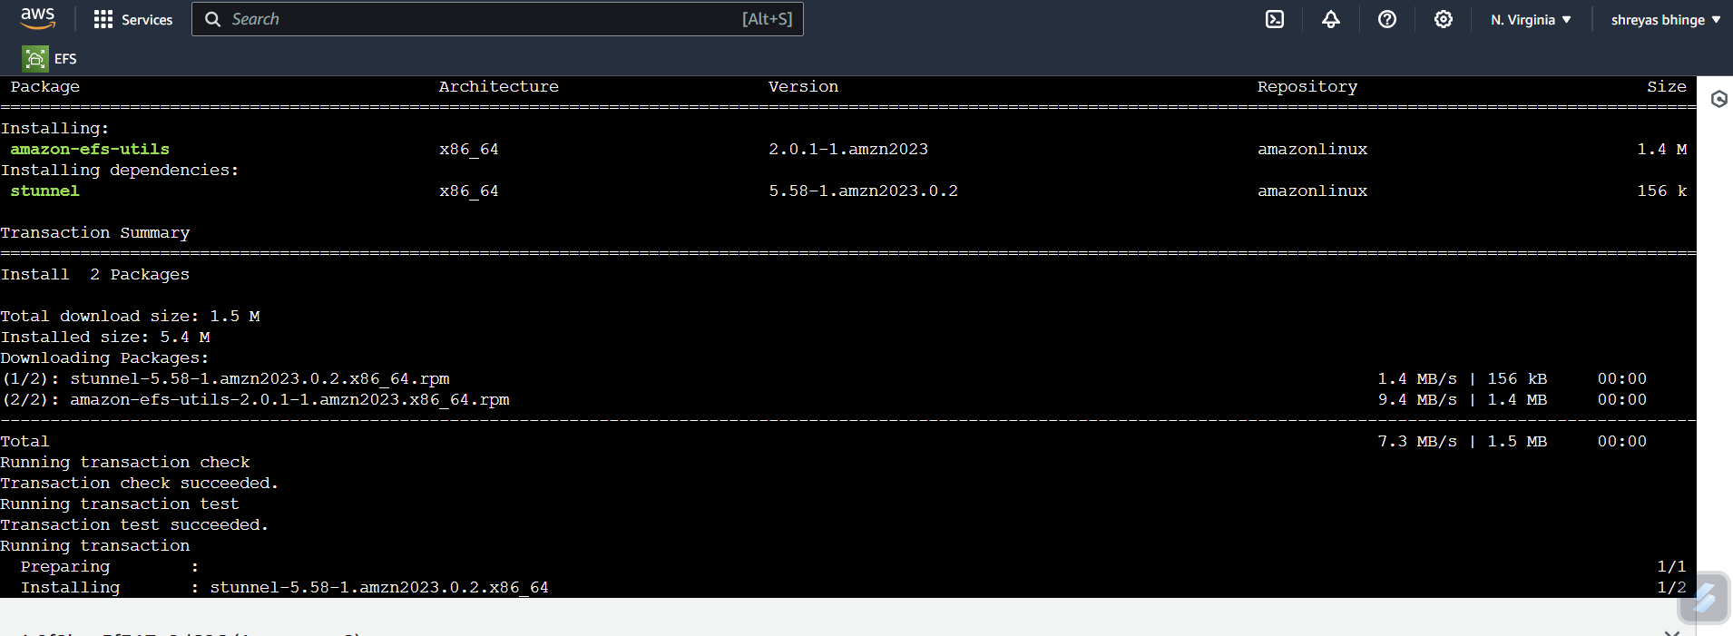

* Create a folder.

Mkdir efs

Next go to the efs file

Copy — Using the EFS mount helper as shown below (use your mount, below is just a sample)

sudo mount -t efs -o tls fs-0318d9f08d1068bd9:/ efs -

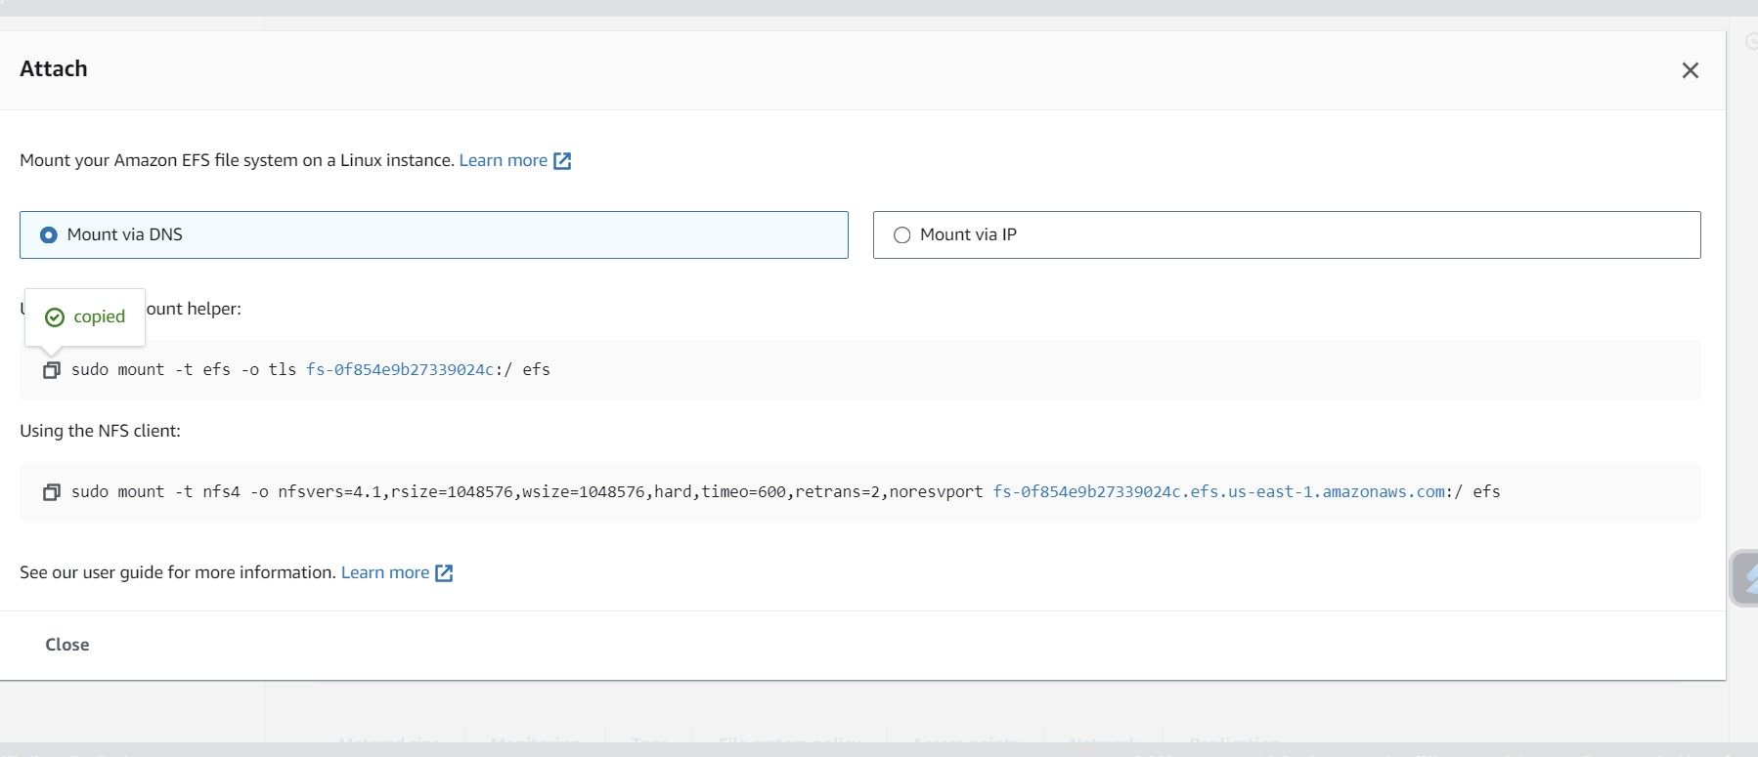

— Use below command to check the mounted files

df -h

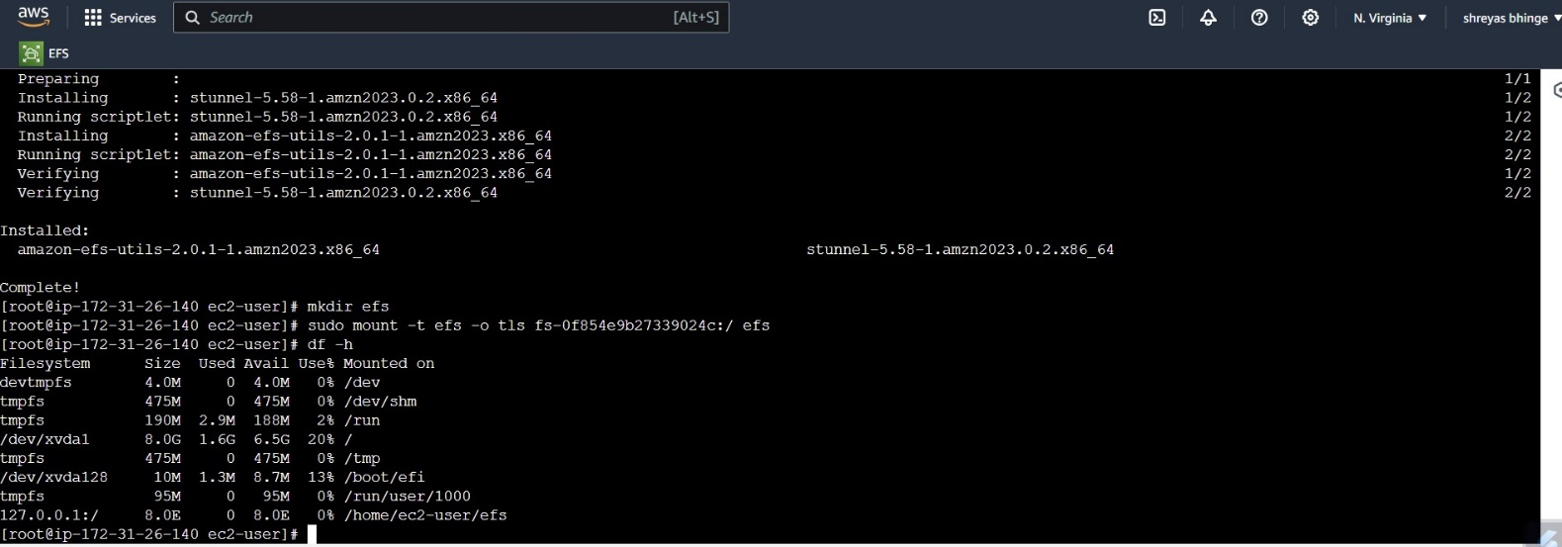

2.Mounting efs to the ubuntu instance and redhat instance

Use below commands to install the required packages to mount efs

sudo apt-get update

sudo apt install nfs-common -y $$ /

sudo systemct1 status nfs-utils

Mount the EFS Drive

Make a folder that EFS will be associated

sudo mkdir /mnt/efs  
sudo mount -t efs -o tls fs-0318d9f08d1068bd9:/ /efs   
cd efs

df -h

